May monthly report
Project Title:
Conversion of post-combustion gas from cement manufacturing to syngas by electrochemical CO₂ capture and reduction
……..........................................................
Dr. Pongkarn Chakthranont
Sothearoth Heng
NCR ID: 803198
Under the supervision of
Dr. Pongkarn Chakthranont
Contract Number: NCR-NN-2023-20170-EN
June 2024

- Tasks list for April
- Improvement of CO2RR performance of Ni_{1.8mgcm-2}-2D-NC catalyst under PCO₂ of 0.15 using pulse electrochemical method:
  - Influence of operation and regeneration times
  - Influence of applied pulse potential
- Investigation of CO2RR performance of additional CALF20 on the GDE as a surface-accessible CO₂ layer under a diluted CO2 condition (PCO₂ of 0.15).
- Experimental Procedure
Preparation of the Ni-2D-NC-CALF20 cathode electrode via spray coating method
The as-prepared Ni-2D-NC-CALF20 catalyst was spray-coated onto Sigracet 39BB carbon paper. Briefly, 80mg of CALF20 powder was ultrasonically mixed with 160µL of Nafion ionomer and 20mL of ethanol. The as-prepared CALF20 solution was then sprayed behind the GDL to get a desired mass loading of 5mg/cm². 150 mg of the Ni-2D-NC and 127µL or 10% by catalyst weight of XA-9 binder were ultrasonically mixed with 10ml of IPA for 60 min to form a dark colloidal solution which was then sprayed onto the front side of the GDL with 0.5 ml/min on 95 °C hotplate to obtain ~ 0.18 ± 0.1 mg/cm².

Electrochemical CO2RR measurements
A 5 cm² MEA electrolyzer was used to evaluate the CO2RR performance under modulated operating conditions. The IrO_{x}/TiPt, AEM (X37-50 Grade RT, Dioxide Materials), and different cathode catalysts were employed as the anode, membrane, and cathode electrode, respectively. 50 ml of 0.5M KOH was recirculated and used throughout the experiment as the anolyte at 8 ml/min. The humidified 15%CO₂/85%N₂ gas stream was introduced into the cathodic inlet under total flow rates of 100 ml/min. Meanwhile, the cathodic outlet was directly injected into an online gas-chromatography for gas products analysis. For the investigation of the impact of applied pulse potential, the pulse CO₂ electrolysis was operated under different applied pulse potential ranges (3.7-0, 1, and 1.5V). Meanwhile, the influence of operation and regeneration times were also studied under different ranges of 60-30s, 6-3s, and 3-1s at applied pulse potential of 3.7-1.5V.

- Results
Pulsed CO₂ electrolysis of Ni_{1.8}-2D-NC with different pulsed potential ranges
The studies of applying a pulsed electrochemical method in our zero-gap electrolyzer system were inspired by several reports indicating improved CO2RR performance, specifically in terms of CO selectivity and long-term stability.^{1–3} This improvement is attributed to the regulation of the cathode surface microenvironment, which not only prevents salt formation but also enriches CO₂ concentration near the catalyst. Figure 1 compares CO2RR performance under static and pulsed conditions, revealing a significant increase in FE(CO) to approximately 70% and enhanced system stability under pulsed electrolysis compared to static conditions. However, we observed that the applied current density in the pulsed condition was lower than in the static condition, which could be a key factor for the higher FE(CO) in the pulsed condition (j(CO)pulsed = ~92 mA/cm² compared to j(CO)static = ~109 mA/cm²). Additionally, pulsed CO2 electrolysis under varying pulsed potentials showed minimal impact on overall cell performance while maintaining good stability. This suggests that it effectively prevents cation and water crossover from the anode side, which could otherwise cause salt formation and GDE flooding during operation.
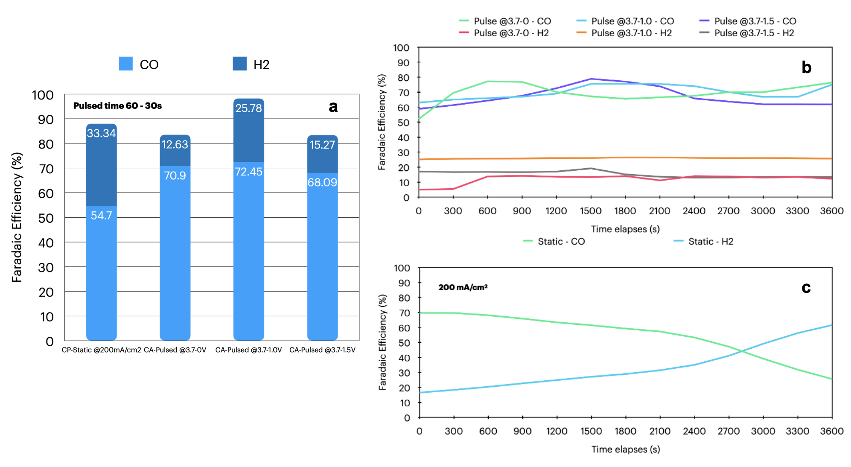
Figure 1. (a) Comparison of faradaic efficiency of Ni-2D-NC under static and pulsed conditions and (b and c) faradaic efficiency of Ni-2D-NC as a function of time under a diluted CO₂ condition at 200mA/cm².

Pulsed CO₂ electrolysis of Ni_{1.8}-2D-NC with different operation and regeneration time
To further investigate factors influencing pulsed CO2RR performance, we conducted pulse CO₂ electrolysis under various pulsed operation and regeneration times. As shown in Fig. 2, the FE(CO) for systems operated with different pulsed time ranges exhibited similar results to those with varying pulsed potential ranges. This suggests that the pulsed electrochemical method does not significantly enhance CO2RR performance under diluted CO₂ conditions; however, it does help prevent salt formation and GDE flooding. Notably, the FE(CO) slightly decreased while the FE(H₂) increased under pulsed conditions with shorter operation and regeneration times compared to longer ones. This phenomenon may be attributed to a higher carbonate concentration at the cathode surface, which leads to increased salt formation and higher HER activity.
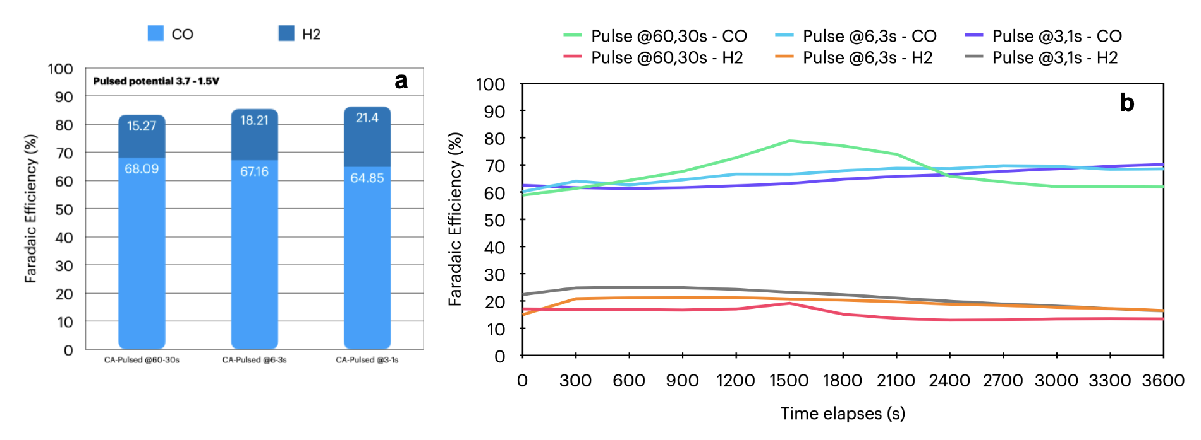
Figure 2. Comparison of faradaic efficiency of Ni-2D-NC cathode under a pulsed condition at different operation and regeneration times.

CO2RR performance of Ni-2D-NC and Ni-2D-NC/CALF20 under a 15%CO2 condition
To further confirm the effect of catalyst mass loading and the surface-accessible CO₂ layer of CALF20, we conducted a CO2RR performance test using Ni-2D-NC with a mass loading of 2.4 mg/cm² and Ni-2D-NC (1.8 mg/cm²) with a 5 mg/cm² CALF20 layer behind the GDL. As shown in Fig. 3, the FE(CO) for the 2.4 mg/cm² Ni-2D-NC catalyst was lower than that of the 1.8 mg/cm² catalyst, indicating that the optimal Ni-2D-NC mass loading is 1.8 mg/cm². Meanwhile, the Ni-2D-NC/CALF20 catalyst exhibited poor CO selectivity with an FE(CO) of approximately 8%, which might be due to the higher thickness of CALF20 obstructing CO₂ access to the catalyst surface, thereby increasing HER activity. Therefore, either the CALF20 mass loading should be reduced, or the carbon paper should be replaced with carbon cloth that has a larger pore size.
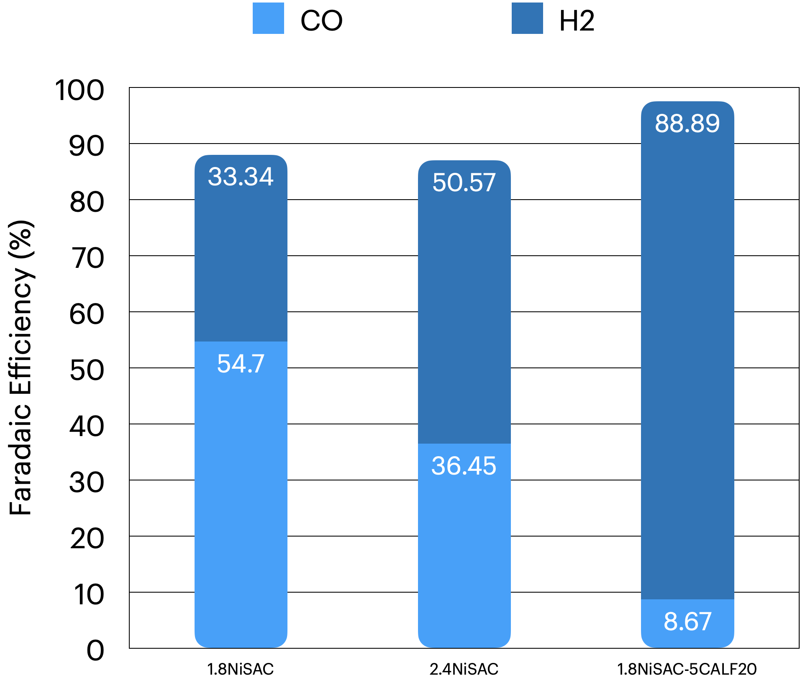
Figure 3. Faradaic efficiency of different cathode materials under a diluted CO₂ condition at 200mA/cm²
- Upcoming tasks
- CO2RR performance under a diluted CO₂ condition:
  - Ni0.5-2D-NC (1.8mg/cm²)
  - Acid-treated Ni-2D-NC (1.8mg/cm²)
  - Ni-2D-NC(1.8mg/cm²) - CALF20 (2.5 and 0.5mg/cm²)
- CO2RR performance under a 95%CO₂/5%O₂ condition at higher current densities

- Refereneces
1. Xu, Q. et al. Enriching Surface-Accessible CO2 in the Zero-Gap Anion-Exchange-Membrane-Based CO2 Electrolyzer. Angewandte Chemie 135, e202214383 (2023).
2. Xu, Y. et al. Self-Cleaning CO2Reduction Systems: Unsteady Electrochemical Forcing Enables Stability. ACS Energy Lett 6, 809–815 (2021).
3. Casebolt, R., Levine, K., Suntivich, J. & Hanrath, T. Pulse check: Potential opportunities in pulsed electrochemical CO2 reduction. Joule 5, 1987–2026 (2021).

